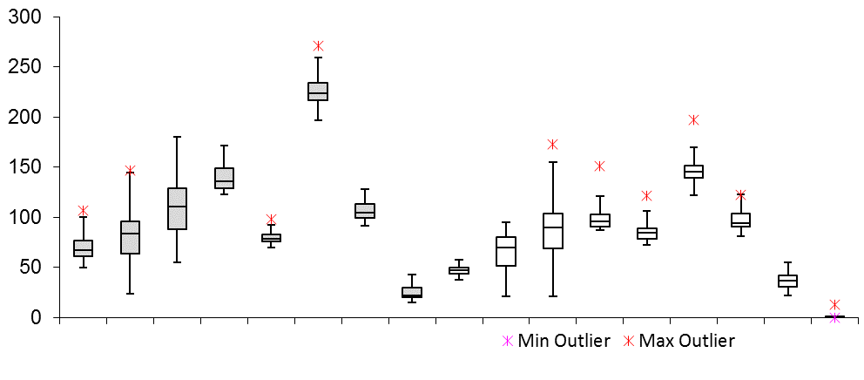

Simple benchmark

Composite benchmark

Left to right: MSM_O, MLite_O, EUML_O,

Sine_N, Sine_O, QM_N, QM_O, Full_N, Full_O

Left to right: MSM_O, MLite_O, EUML_O,

Sine_N, Sine_O, QM_O, Full_N, Full_O

execution time (ms)